TOORMINA HIGH SCHOOL

2018 STUDENT INFORMATION HANDBOOK

Welcome to Toormina High School,

Our school is a comprehensive co-educational secondary school with a Learning Support Unit that provides high quality educational programs for all students in years 7 – 12. With a proud tradition of academic, sporting and performing arts excellence, we encourage all students to become actively involved in the academic and extra-curricular activities available.

Our school motto, ‘Creating our Future’, is the core vision of our teaching, preparing each student as future focussed learners. We value the contribution that each student makes to our school, supporting their intellectual, social, physical and moral growth as we develop each student into responsible adults. To achieve this, we work in partnership with parents, engaging strategies that challenge students to achieve excellent results.

We offer a range of programs that support all students in their development, including an After School Homework Centre, intensive Literacy and Numeracy Programs and Program Based Learning in year 7 and 8. We proudly teach our year 7 students Gumbaynggirr language.

The Learning Support Unit provides high quality differentiated learning opportunities for each student through the development of comprehensive individual learning plans, collaboratively developed with parents and students, ensuring each student’s learning needs are achieved and students are well prepared to be active and engaged members of the community beyond school.

We provide contextually appropriate learning opportunities beyond the classroom through a variety of excursions that immerse students into the world beyond the classroom. I strongly encourage each student to make a positive mark on our school by engaging in the opportunities available to them throughout their school life and striving to achieve their personal best.

This information booklet offers parents, carers and students information that will support the transition from primary school into high school. It contains information regarding our school faculties, subject requirements and the staff who will be teaching and supporting you.

On behalf of all of the staff at Toormina High School, we look forward to working with you and your family to create a successful transition to Toormina High School.

Regards

Mr Paul Humphrey

Principal

Table of Contents

PRINCIPAL'S MESSAGE 1
TABLE OF CONTENTS……………………………………………………………………………..…… 2, 3
SCHOOL VISION 4
SCHOOL AIMS 4
CORE VALUES 4
STUDENT CODE OF GOOD CONDUCT 5
SCHOOL DIRECTORY 6
SCHOOL UNIFORM 7,8
ACADEMIC AWARDS – YEARS 7 to 10 9
STUDENT WELFARE and WELLBEING 10,11
GENERAL INFORMATION 12
Absences 12
Assemblies 12
Bicycles and Scooters 12
Bus Travel 12
Canteen 12
Computer Network 13
Examinations 13
Homework/Study Habits 13
Homework Centre……………………………………………………………………………….…13
Late to School 13
Leave Passes 14
Library 14
Lockers 14
Medication and Medical Conditions…………………………………………………………..14
Mobile Phones/IPods and other electronic devices 14
Movement between Lessons 14
Parent Teacher Evenings and Individual Appointments 14
Positive Behaviour for Learning……………………………………………………………….....15
P & C Association 15
Reports 15
Security 16
Sick Students 16
School Socials 16
Skoolbag………………………………………………………………………………………….….15
Sport 16
Newsletter/Website 16
School Contact Details 16
SCHOOL AND SUBJECT CONTRIBUTIONS 16
STUDENT LEADERSHIP and CITIZENSHIP 18
Students Executive Team…………………………………………………………………………17
Student Representative Council (SRC) 18
IMPORTANT DATES 19
BELL TIMES 19
SCHOOL MAP 19
SKOOLBAG INSTALLATION INSTRUCTIONS……………………………………………………………20

SCHOOL VISION
Toormina High School is a
learning community committed
to achievement, excellence and care.

THIS SCHOOL STRONGLY SUPPORTS THE FOLLOWING PRECEPTS
- Encouragement of the pursuit of excellence.
- A positive and co-operative environment for teaching and learning.
- A fair discipline policy that incorporates student wellbeing in a framework of clearly stated expectations.

SCHOOL AIMS
- The growth of the individual student towards full maturity as an intellectually capable, socially and physically able and morally responsible person who will be able to participate in and cope with a changing society in a meaningful way.
- The professional development of the staff as a whole and individually.
- Meaningful interaction with the schools wider community and an educational focus on global citizenship.

CORE VALUES

- Quality Learning - We value quality learning, which will enable all to achieve their potential.
- Respectful Relationships – We value a community with positive relationships, which enables all to participate and to develop care, respect and tolerance for others.
- Creating Our Future – We value individuals who have a commitment to making a positive contribution to other people, the school and the wider society.

STUDENT CODE OF GOOD CONDUCT
Toormina High School is a place of learning where caring relationships and a safe and clean environment are highly valued. The following code is to assist students to show pride in and contribute fully to the life of our school.

Quality Learning Will Be Achieved By:
- Producing your best work at all times.
- Promoting and contributing to the best work of others.
- Respecting the rights of others to learn.

Respectful Relationships Will Be Developed By:
- Respecting all members of the school community.
- Using respectful language at all times.
- Considering others at all times.

A Safe And Clean Environment Will Be Maintained By:
- Following instructions.
- Respecting school buildings, grounds and equipment.
- Valuing our environment.

Good Student Conduct Is Demonstrated When:
- I follow instructions from staff.
- I wear the appropriate Toormina High School uniform at all times, unless excused by the Principal.
- I arrive on time and am well prepared for all classes and school activities.
- I am aware of and follow the rules of safety, hygiene and movement throughout the school.
- I ensure respectful communication with my fellow students, parents and school community.
- I consider others in my playground behaviour and movement around the school.
- I use study times and allocated areas effectively and appropriately.
- I bring a note from my parent/guardian, explaining absences/lateness, on the next day of attendance.
- I only leave the class or school grounds with written permission.
- I participate in school decision-making and respect school policies.

Students Are Expected To:
- Be prepared to work and learn.
- Bring all necessary equipment for class.
- Be respectful, cooperative and courteous at all times.
- Use respectful language.
- Be safe in the classroom and playground.
- Wear school uniform.
- Remove hats before entering class.
- Use toilets during breaks.
- Have no chewing gum at school.

SCHOOL DIRECTORY
PRINCIPAL | Paul Humphrey
DEPUTY PRINCIPAL | Melanie Murray
DEPUTY PRINCIPAL | Michelle Elliot
HEAD TEACHERS
ENGLISH | Lisa Mullan | English Staffroom
MATHEMATICS | Craig Holden | Mathematics Staffroom
SCIENCE  HUMAN SOCIETY IN ITS ENVIRONMENT | Jenny Bryant  Bronte Kedraika | Science Staffroom  English/HSIE Staffroom
TECHNICAL & APPLIED STUDIES | Greg Woods | TAS Staffroom
CREATIVE & PERFORMING ARTS | Anna McAuley | Art Staffroom
PDHPE/SPORT | Simon Bilsborough (Acting) | PE Staffroom
SUPPORT UNIT | Chris Browne | Support Staffroom
WELLBEING | Laura McRae | Administration Block
ADMINISTRATION/CURRICULUM | Cheryl Cutter | Administration Block
YEAR ADVISERS
YEAR 7 | Adam Berrada  Matt Ryan | PDHPE Staffroom  Science Staffroom
YEAR 8 | Matt Gray  Bree Taylor | English Staffroom  English Staffroom
YEAR 9 | Leanne Firkins  Sue Jordan | English Staffroom
YEAR 10 | Kyah Schwartz  Sheridan Johnston | PDHPE Staffroom  PDHPE Staffroom
YEAR 11 | Adrienne Gillingham  Andy Robb | Library  HSIE Staffroom
YEAR 12 | Joe Anderson  Lucy Thomas | Mathematics Staffroom  Science Staffroom
SUPPORT STAFF
ABORIGINAL EDUCATION OFFICER | Judith Peen | Mathematics Staffroom
CAREERS | Robyn West | Careers Office
INFORMATION TECHNOLOGY | Kathryn Gibney | Administration Block
COUNSELLOR |  | Administration Block
ELECTIVE CHOICES | Yr 7, 8, 9, 10 - Cheryl Cutter  Yr 11, 12 - Robyn West | Administration Block  Careers Office
LEARNING AND SUPPORT | Leanne Firkins | English Staffroom
SICK BAY | Administration Staff | Front Office
FIRST AID | Gillian Kelly | Front Office/Library
ENROLMENTS, BUSES, PAYMENTS | Administration Staff | Front Office
LATE NOTES | Reception Desk | Front Office
LEAVE PASSES | Deputy Principals | Administration Block
LOST PROPERTY | Administration Staff | Front Office
STUDENT REPRESENTATIVE COUNCIL | Tanya Cheers | TAS Staffroom
TRANSITION ADVISER | Matt Francis | Careers Office

SCHOOL UNIFORM

All students are required to wear only approved school uniform items. The wearing of full school uniform by all students enhances school tone and the morale of staff and students. We want the calibre and achievements of our students to be fully recognised and appreciated by the wider community, and we recognise that the dress of our students very much shapes the perception of our school by the community.

- Approved school uniform dress items are listed below.
- Hooded, coloured or printed (other than the school logo) tops are NOT part of our uniform, and are NOT to be worn.
- Families can apply for Student Assistance if they have trouble affording uniform items.
- Students unavoidably out of uniform should have a note from a parent/carer, and show it to the Head Teacher Wellbeing who may offer them clean uniform items to wear that day.
- Occupational Health & Safety Requirements stipulate that students must wear enclosed shoes at all times.
- Uniform needs to be modest at all times.
- Excessive jewellery may also present an OH&S hazard and students may be requested to remove such items.
UNIFORM OPTIONS
The Toormina High School Uniform Shop is open every Monday from 8:00am to 4:00pm, manager Karina Allen, 0468 436 217.
Junior girls - unisex THS polo shirt, unisex THS black shorts, junior girls THS skirt, black THS track pants, black THS jumper or jacket, covered black shoes.

Senior girls - unisex THS shirt, unisex black THS shorts, senior THS white blouse, senior maroon THS skirt, black THS track pants, black THS jumper or jacket, covered black shoes.

Junior boys - unisex THS polo shirt, unisex THS black shorts, junior boys button shirt, black THS track pants, black THS jumper or jacket, covered black shoes.

Senior boys - unisex THS shirt, unisex black THS shorts, senior THS White button shirt, black THS track pants, black THS jumper or jacket, covered black shoes.

Sports uniform - unisex THS shirt, unisex black THS shorts, black THS track pants, black THS jumper, sports shoes.

UNIFORM OPTIONS

Junior and senior student uniform options.
s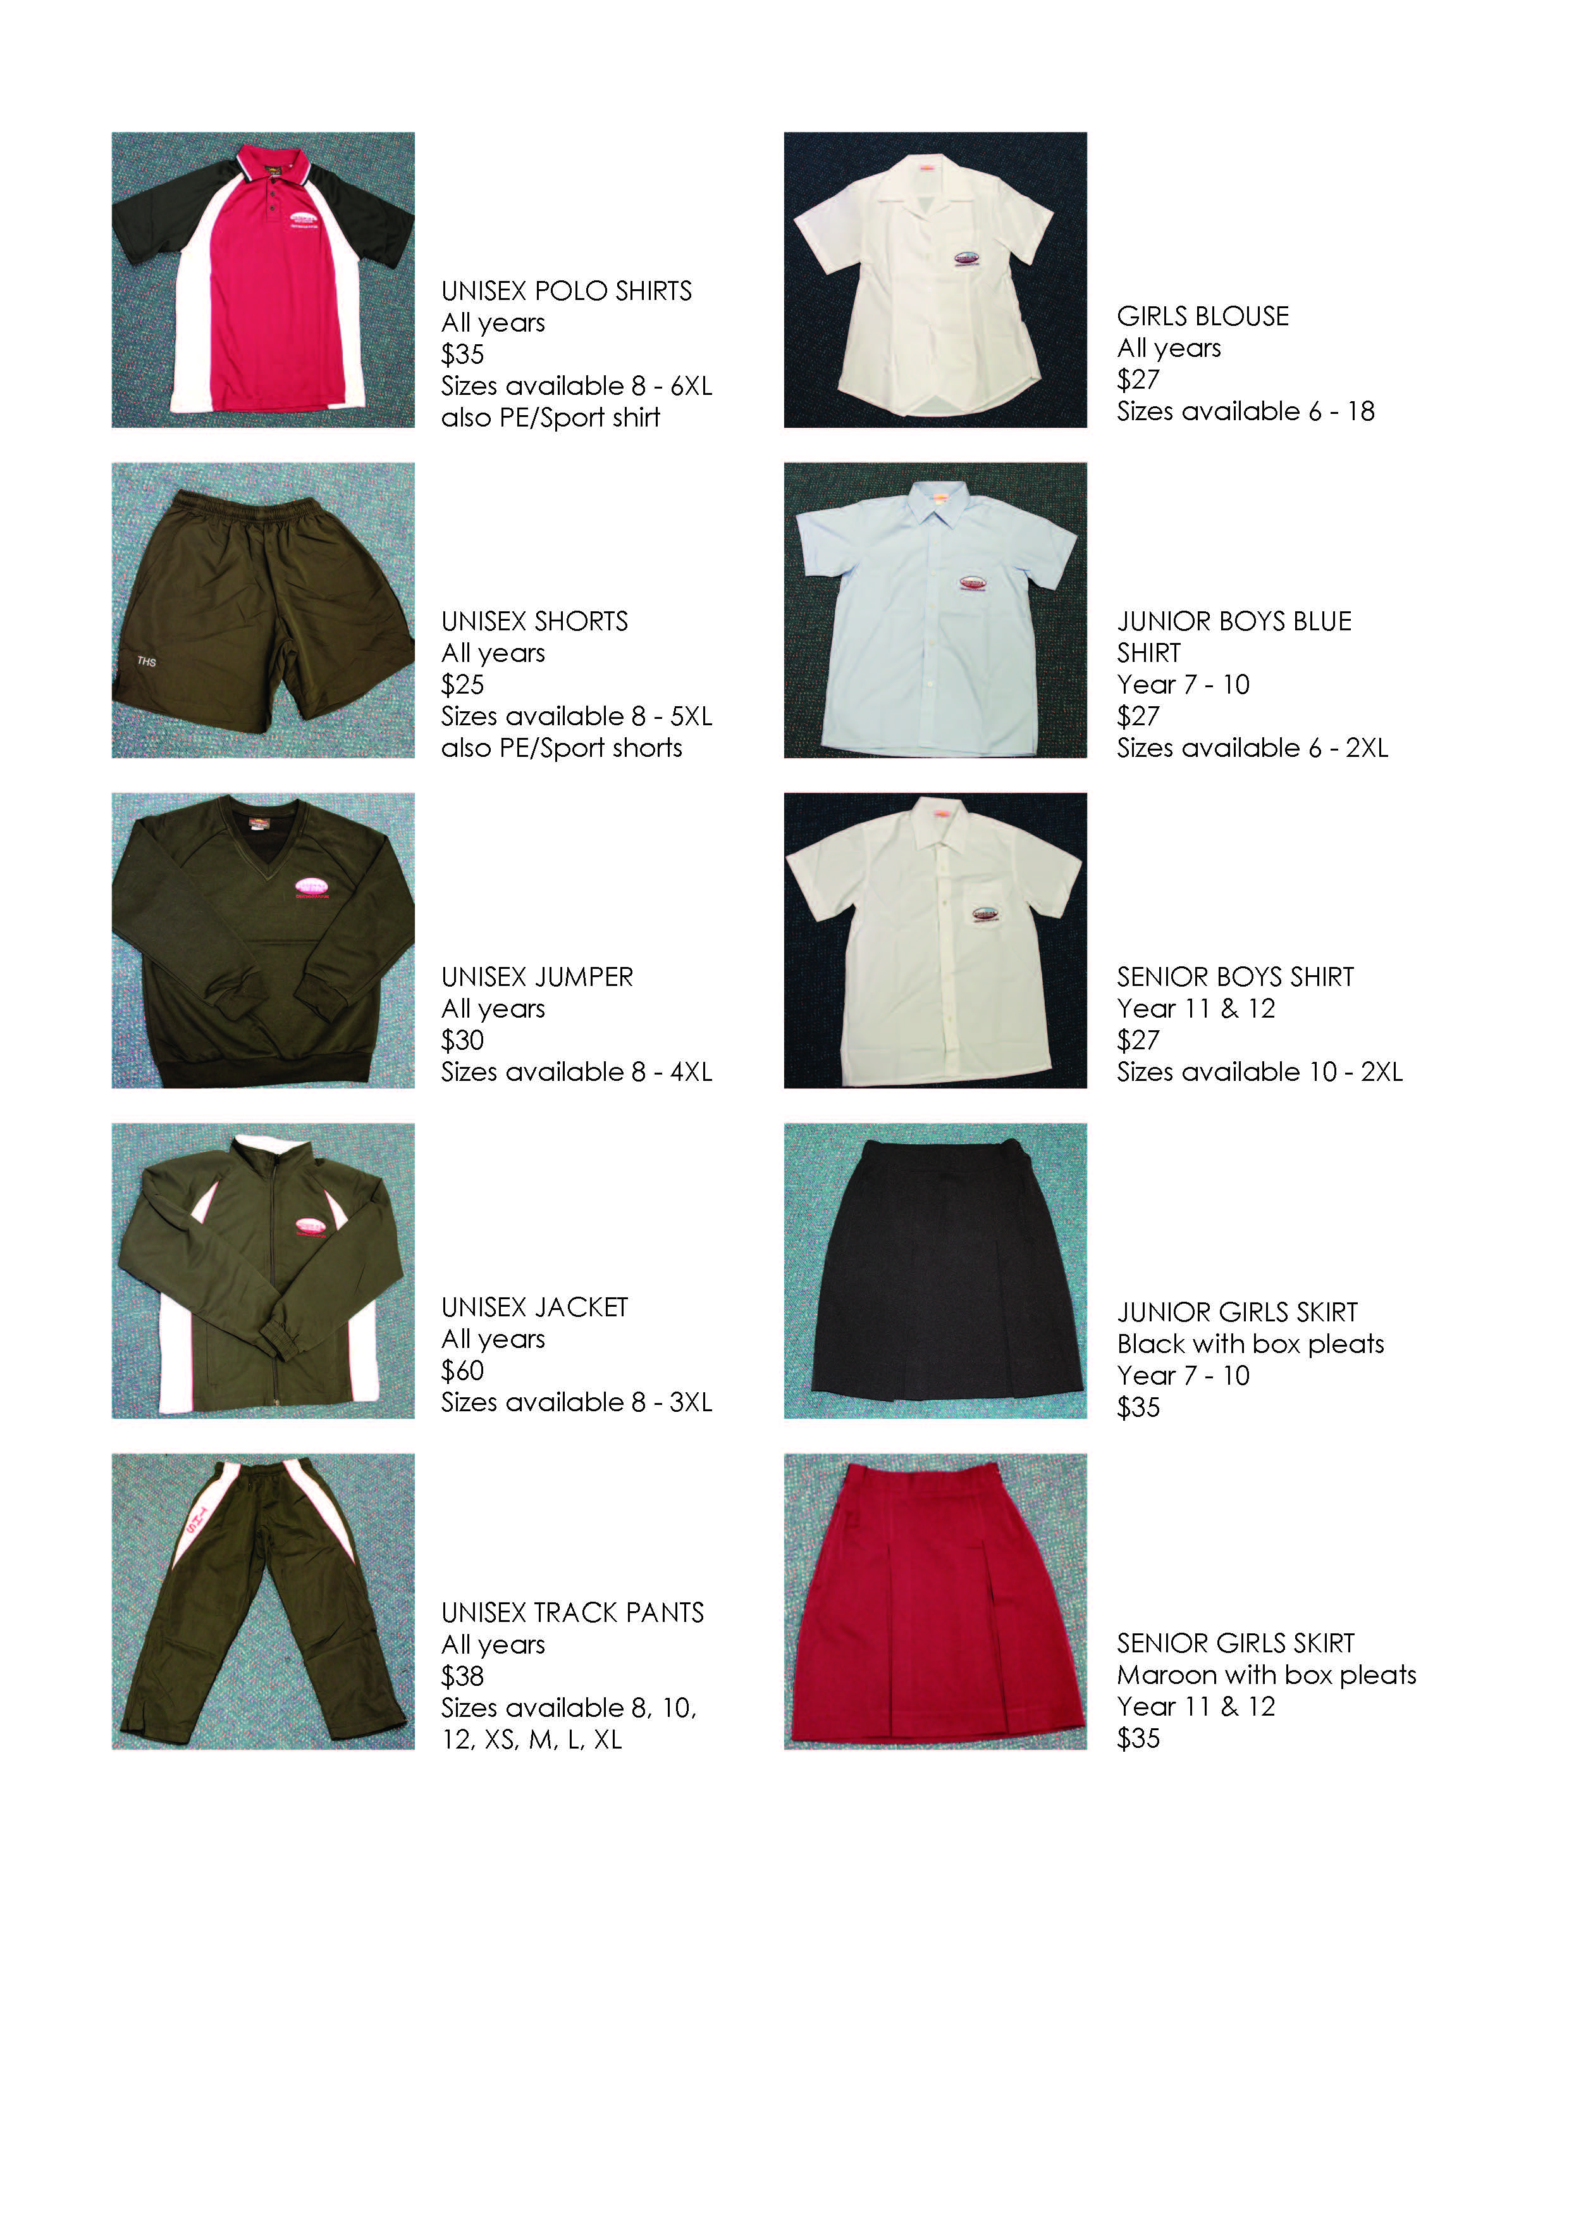

ACADEMIC AWARDS – YEARS 7 to 11

Each semester Toormina High School holds Academic Achievement Assemblies:

The Minor Awards assemblies are held in year groups, and based on your academic effort and achievement you may receive a Merit or Encouragement award.

The Major awards assemblies are for the whole school to celebrate the achievement of the students who achieve Outstanding Academic Achievement awards, as well as outstanding sporting and community awards.

Semester Reports will show one of the following awards for each subject:

Outstanding - The student has an extensive knowledge and understanding of the content and can readily apply this knowledge. In addition, the student has achieved a very high level of competence in the processes and skills and can apply these to new situations.

High - The student has a thorough knowledge and understanding of the content and a high level of competence in the processes and skills. In addition, the student is able to apply this knowledge and these skills to most situations.

Sound - The student has a sound knowledge and understanding of the main areas of content and has achieved an adequate level of competence in the processes and skills.

Basic - The student has a basic knowledge and understanding of the content and has achieved a limited level of competence in the processes and skills.

Limited - The student has an elementary knowledge and understanding in few areas of the content and has achieved very limited competence in some of the processes and skills.

Reports will also show examination mark and class assessment ranking.

STUDENT WELFARE and WELLBEING
Student welfare is a high priority at Toormina High School. Every student has the right to be and feel safe, to be happy and to be given the opportunity to achieve his/her potential. Students who feel that their wellbeing is at risk, particularly if they are being bullied or harassed, should immediately notify their parents/carers and an appropriate person at school that is, a teacher, year adviser, head teacher wellbeing, school counsellor or senior executive personnel. Bullying is dealt with in a way which recognises the needs of both the victim and the bully so that a lasting resolution of conflict can be achieved.

Head Teacher Wellbeing – Laura McRae
The Head Teacher (Wellbeing) is responsible for the general supervision and welfare of students in the school and is available to assist any students with any problems they may have in or out of school.

Year Advisers and Assistant Year Advisers
This school has, as members of the teaching staff, six Year Advisers. These Advisers are appointed primarily to assist pupils with their progression through their school life. They are available for interview, to assist and advise in the following areas:

(a) Personal and educational problems, including choice of subjects and courses of study.
(b) Problems related to school uniform and general conduct.
(c) Problems associated with attendance, punctuality and absentee notes.
(d) Changes from one class to another.

School Counsellors
Students are referred to the School Counsellor by teachers, parents, Child Welfare Services or students themselves. The School Counsellor is concerned with psychological welfare, diagnoses of educational and adjustment issues. Counsellors are available for interview with parents. Prior appointment must be made by telephoning the school.

Careers Adviser – Robyn West
The school has a full time careers adviser who provides information, guidance and advice to help students explore their education and career options, create a resume, search for jobs, apply for jobs and/or apply for further study. Parents may phone for interviews if desired.

Learning Support Team – Leanne Firkins
Learning support at Toormina High School is available to students according to need.
Leanne is the co-ordinator of the Toormina High School Learning Support Team (LST). The LST co-ordinates and targets support across the school. It ensures the provision of appropriate resources and monitors their use to meet identified student needs.

LAST – Learning and Support Teacher – Leanne Firkins
The Learning and Support Teachers provide learning support for students in years 7-12 who are experiencing difficulty in accessing the curriculum. LAST teachers work predominantly within a classroom setting, and focus on strengthening literacy and numeracy skills. They manage the implementation of Special Provisions for examinations for students with an identified need. They also complete learning assessments for students in Years 7 to 12.

Aboriginal Programs – Judith Peen
The Aboriginal Education Officer, Judith Peen, works in class and withdrawal settings to support Aboriginal students.
THS Aboriginal Education team assists Aboriginal students, and their parents, transition from primary school to Toormina High School. We host regular morning teas ‘Yarning Ons’ for community members and staff. Our community also join us to celebrate NAIDOC week. The local Gumbaynggirr language is taught as part of our Languages Other Than English Program.
THS also run groups in Girls Dance, Art & Craft and a Boys Didge Workshop. Our Indigenous students participate in A.I.M.E, the Australian Indigenous Mentoring Experience which supports students to proceed to study at a university level after high school.

Support Classes – Chris Browne, Head Teacher Support
Students with a mild intellectual disability (IM) are supported in a class with a specialist teacher and SLSO (School Learning Support Officer). Students may study at a Life Skills or mainstream level as indicated by a Personal Learning Plan. Students may attend mainstream classes also indicated in their Personal Learning Plan.
Students with more significant intellectual disability or autism are given high level support in discrete classes and follow a special program of study, accessing mainstream classes, as outlined in their Personal Learning Plan.
Students with Funding Support receive support during the transition from primary school to Toormina High School.

Itinerant Support Staff
Specialist support teachers and Student Learning Support Officers assist students with sensory needs as outlined in their Personal Learning Plans.

GENERAL INFORMATION

Absences
Parents are asked to provide an explanation for an absence within 7 days - this can be done by telephone, via Skoolbag (see page 16), note, email, fax or by replying to a received SMS which are sent out daily. Our school participates in an SMS-based system which enables us to give parents instant feedback when their child is absent from school. SMS messages are automatically generated each day from the Sentral Roll – when a student is marked absent at roll-call.
If there is no reply after 7 days the absence will be recorded as ‘unjustified’ on the school’s official roll and DoE system. In cases of absence for students in Years 11 and 12 who are absent when assessment tasks are due, they may be asked for a medical certificate (see separate Assessment Policy document).

Assemblies
School assemblies are held every Tuesday in the main assembly area. Year group assemblies are conducted periodically by Year Advisers. Special assemblies for awards will be convened as required.

Bicycles and Scooters
Bicycles and scooters must not be ridden in the school grounds. Students are to walk their bikes/scooters to the bike area, where they should be secured with a lock and chain. The bike area is then out of bounds to all students until the end of the school day.
The school has constructed a bicycle shelter to try to provide security, however, it cannot be guaranteed. The shelter will be locked each day. Bicycles cannot be removed from the shelter during the day, unless there is an emergency. In such a case the student requiring the bicycle/scooter is to see the front office.
Students who have permanent early leave passes or students who have to leave early on a given day (a one-off situation) can secure their bicycles to the two racks provided on the outside of the shelter.
Skateboards are not to be brought to school.

Bus Travel
Students living outside a 2.0km radius or 2.9km walking distance from the school are entitled to free bus travel. Year 6 - 7 students or new enrolments who have had a bus pass in the previous year need to update their information online https://apps.transport.nsw.gov.au/ssts/updateDetails
Students who are applying for free bus travel for the first time can apply on line at transportnsw.info/school-students or call 131500 for assistance.
Students who are in a shared parenting situation and need to travel from two addresses need each parent to make a separate application for each address online.
Bus passes are expected to be shown to driver on each bus trip. If you lose your pass you can apply and pay online.
For details:
Busways North Coast P/L Forest Coaches Forest Coaches Newcombe Coach
(Formerly Sawtell) (Formerly Ryan’s)
4 O’Keefe Drive 9 Newcastle Drive 9 Hurley Drive 40 Industrial Drive
COFFS HARBOUR SAWTELL COFFS HARBOUR COFFS HARBOUR
6652 2744 6653 3344 6653 7261 6652 3201

Canteen
The canteen serves a wide variety of hot and cold foods, drinks and snack foods. Lunch orders may be placed before school or in the 20 minute recess.

Computer Network
Year 7 students will be provided with assistance early in Term 1 to familiarise them with the logon process. When students sign out of the school their network account is automatically deleted. Students are able to Bring Your Own Device (BYOD), specifications for suitable devices are available on the THS website.

Emergency Contact
If a parent or caregiver needs to contact a student at school as a result of an emergency, they are required to call the school’s main office and a written message will be sent immediately to the student. If a student needs to make emergency contact with anyone they can do so through the school’s main office. Students are not permitted to call a parent/carer on a mobile phone to arrange for the parent to collect them from school. If a student is sick, the class teacher or deputy will direct them to the front office.

Examinations
Examinations are held for each subject each semester during the nominated examination week.
Formal examinations are held in the school hall for years 9-12.
There are also the following external examinations for students:
National Assessment Program Literacy and Numeracy (NAPLAN) – Years 7 and 9.
Science Validation of Assessment 4 Learning and Individual Development VALID - Year 10 & 8

Homework/Study Habits
Desirably, homework should be done each night. Homework should involve revising, summarising and learning notes and work completed during the day. It may include reading of books, learning of spelling and preparation of work.

Homework Centre and after school activities
Qualified teachers from a range of faculties are available in the library at the Homework Centre for extra tuition on Monday afternoons, 3:30 - 5:00pm and a Mathematics Homework Centre operates on Thursday afternoons, 3:30 - 5:00 pm.
Tuesday afternoons, 3:30 - 5:00pm, the TAS faculty run a Makerspace for students interested in electronics and robotics and on Monday afternoons we have Active Arvos providing supervised, fun, physical activities, 3:30 - 4:30pm.

Late to School
Students arriving late to school must have a note from their parents/guardians explaining the reason for the late arrival. Late students go straight to class until 9:15am, after 9:15 students must go to the front desk in the school office. No explanatory note means this will be marked as ‘absent unjustified’ on the DoE system.

Leave Passes
Students seeking permission to leave school during the day are to present a note from their parents to the Deputy Principal before school commences. Leave Passes will only be issued for special occasions. Parents and students are asked to try to keep medical and dental appointments outside of school hours.
If leaving school early, students must possess a School Leave Pass for partial absence which will be issued at the front office after permission has been granted by the Principal or Deputy Principal.

Library
The Library is open before school, at recess and lunch time (excluding Wednesday recess). After school use may be possible by arrangement.
Students are welcome to access all the library resources. Books are available for borrowing. Current magazines, periodicals, daily newspapers, videos, computer programs and the internet are available for use in the library. Students will need to see the Librarian in order to access the computers as they are very popular. The library also provides a quiet haven for reading or studying.

Lockers

School lockers are available for $5 per year.

Medication and Medical Conditions All students requiring medication to be administered during the school day must hand it in to the front office first thing in the morning with a permission note from parents. Where the medication has been prescribed by a medical practitioner a note from the doctor including dosage requirements must be included.

If a student suffers from a serious or chronic condition (such as allergies, asthma or epilepsy) it is necessary that parents inform the school of the condition as soon as possible and, when necessary, provide medication and an action plan formulated by the family doctor. If you have any questions or concerns please contact the school on 6653 3077.

Mobile Phones/iPods and other electronic devices
Toormina High School acknowledges that students may wish to use a mobile device for educational purposes whilst at school. If students bring these devices please be aware that they do so at their own risk. Students who fail to comply with teacher directions to put their mobile device away may have it confiscated, as indicated by the Department of Education. The teacher will take it to the front office and record the details. The device can be collected from the school office at the end of the day. Repeat offenders will face further disciplinary action according to the Department of Education’s Student Discipline in Government Schools Policy.

Movement between Lessons
Bike area is out of bounds during school time.
CORRIDORS AND OPEN AREAS are out of bounds during RECESS and LUNCH (during wet weather Years 7 and 11 may sit in the Social Sciences, Art and Music corridor. Years 8, 9 and 10 may sit in the Mathematics and Science corridor.
SCHOOL GROUNDS – students must NOT leave the school grounds unless they are either:
- Accompanied by a teacher.
- Going on an excursion/sporting trip/PE; or
- Leaving for a valid reason and have a Leave Pass indicating time of departure.

Positive Behaviour for Learning

In 2018, Toormina High School will implement Positive Behaviour for Learning, known as PBL. It is an evidence-based whole school systems approach that:

addresses the diverse academic and social needs of every student to support them to be successful

supports students in early childhood settings through to senior years of schooling

enables schools to establish a continuum of supports that are intensified to meet the needs of every student​

is team driven, using a problem solving approach (data, systems and practices) that engages students, parents and all school staff

establishes positive social expectations for all in the school community

provides a framework for the school and its community to collectively support the wellbeing of every student.

PBL will enable:

students to respond positively as they have been taught what is expected of them

staff to deliver consistent responses to student learning and behaviour

students to feel safe and cared for at school. Their parents, family and community are more involved in their school.

Parent Teacher Evenings & Individual Appointments Toormina High School works closely with its parent community and welcomes parent involvement in the education of our students. If you would like to talk to a teacher or a member of the school executive about your child's progress Parent Teacher Evenings are conducted twice a year; alternatively parents can contact the school on 6653 3077 to arrange a mutually acceptable time for an appointment.

P & C Association
All parents are urged to join the P & C Association for a fee of $2.00 per family. P & C meetings are held in the Staff Common Room. Parents are encouraged to come along and have their say in matters involving their children. For more details telephone the school or check THS website for meeting dates.

Reports
School Reports are posted out as follows:

Years 7 – 10 Semester 1 Report posted in Week 2, Term 10
Semester 2 Report posted in Week 10, Term 4

Year 11 Interim Report posted in Week 10, Term 2
Preliminary Report posted Week 4, Term 4

Year 12 Interim Report posted Week 5, Term 2
Final Report handed out Week 10, Term 3

Security
The school gates are locked between 9.30am and 3:00pm, with the exception of the main front gate leading to the Administration Office.
All visitors to the school are asked to report to the Front Office upon arrival.

Sick Students
Students who are injured or become sick at school are to report to the Front Office. In general, please do not send children to school if they are sick in the morning. Parents will be asked to collect their children from school if they are too sick to return to class from sick bay.

School Socials
School Socials are held regularly. These are for current Toormina High School students only. Teachers give up their own time to organise and supervise School Socials. No student will be released until the social has finished. Socials run from 6:00 p.m. – 9:00 p.m. Strict rules of behaviour and attendance are applied. Tickets have to be purchased prior to the School Social.
No tickets are sold ‘at the door’. Students on a current yellow or pink card are NOT permitted to attend.
Skoolbag Skoolbag is a free app for your smartphone, ipad or tablet which allows you to receive alerts and information instantly from our school. We encourage everyone to install Skoolbag. This is an easy, cost effective means of communication for THS. Skoolbag will be used for all emergency communication. Simple installation instructions are on the back of this booklet, the THS website or contact the school on 66533077.

Sport
Sport is a compulsory part of the curriculum and is held on Wednesday afternoon for Years 7, 8, 9, and 10. All students participate in Swimming and Athletic Carnivals - participation in Cross-Country is optional.
Problems have arisen in the past with pupils requesting leave on Wednesday afternoons. It would be appreciated if parents could avoid making appointments for the children during this time.
The school offers a wide variety of both recreational and team sports. Special arrangements are made during wet weather.
During sport periods Year 7 students participate at school and will sample and learn rules and skills for most of the sports that are available as choices in future years.

Sport Houses: The four Houses were formed on the basis of the first letter of your surname:
A – D Barramundi Colour - Red
E – K Marlin Colour - Blue
L – R Nannygai Colour - Yellow
S – Z Trevally Colour - Black & White

THS Newsletter and Website
The school newsletter is sent via email and Skoolbag every fortnight. Please ensure our school office is notified of any changes to your email address, phone number and all contact details (and emergency contact details).
If you would like to have a hard copy of the newsletter mailed to you please contact the school on 66533077. The newsletter is also available via the Toormina High School website www.toormina-h.schools.nsw.edu.au which also has important dates, photos, news and information.

School Contact Details
Telephone: 02 66533 077
Fax: 02 6658 2310
Email: toormina-h.school@det.nsw.edu.au
Website: www.toormina-h.schools.nsw.edu.au
Facebook: ‘Like’ & ‘share’our posts on our official Facebook page which has the school logo.

SCHOOL AND SUBJECT CONTRIBUTIONS

General Contributions
Year 7 $40.00 per year
Years 8, 9 & 10 $50.00 per year
Years 11 & 12 $60.00 per year

Subject Contributions for Year 7
Technology Mandatory
Fees are $45.00 per year.
Music Mandatory
Fees are $10 per year.

Subject Contributions for Other Years
Approximate costs for elective subjects have been printed in the Subject Selection Handbooks. Statements will be forwarded to parents in Term 1 listing contributions.

STUDENT LEADERSHIP and CITIZENSHIP

Students at Toormina High School are expected to display and ‘grow into’ citizenship and leadership roles. Students are expected to make a contribution to their school and community. Students may develop their leadership skills through peer tutoring, Student Representative Council.

Student Executive Team

The Student Executive Team are a group of students elected by their cohort and staff that play an integral role in the running of school functions and represent the school in the wider community. The Student Executive Team are a visible force within the school, acting as positive role models for the younger students. They also work closely with the school's SRC to coordinate large fundraising efforts and school projects.​

Student Representative Council (SRC)
The Student Representative Council, representing the student body, meets regularly. Students are encouraged to make suggestions to improve the school or if they have a problem to contact the SRC Representative and the matter can be discussed at the SRC Meeting.
The SRC also conducts fund raising activities throughout the year to raise money for student needs and for charities.

How do you join?
Student representatives are elected after a self-nomination process.

IMPORTANT DATES
Student TERMS 2018
1) 30/1/18 – 13/04/18 | Year 7 return on Tuesday, 30 January  Year 11 & 12 return Wednesday, 31 January  Year 8, 9 & 10 return on Thursday, 1 February
2) 01/05/18 – 06/07/18 | All students return 01/05/18
3) 24/07/18 – 28/09/18 | All students return 24/07/18
4) 15/10/18 – 19/12/18 | All students return 15/10/18

PUPIL FREE DAYS/ School Development Days
Term 1 Monday, 29 January 2018
Term 2 Monday, 30 April 2018
Term 3 Monday, 23 July 2018
Term 4 Thursday, 20 December 2018 & Friday, 21December 2018

PUBLIC HOLIDAYS
Anzac Day Wednesday, 25 April 2018
Queen’s Birthday Monday, 11 June 2018
Labour Day Monday, 1 October 2018

BELL TIMES
The school operates on a fortnightly timetable – Week A and Week B. Each term will commence with a Week A timetable followed by a Week B.
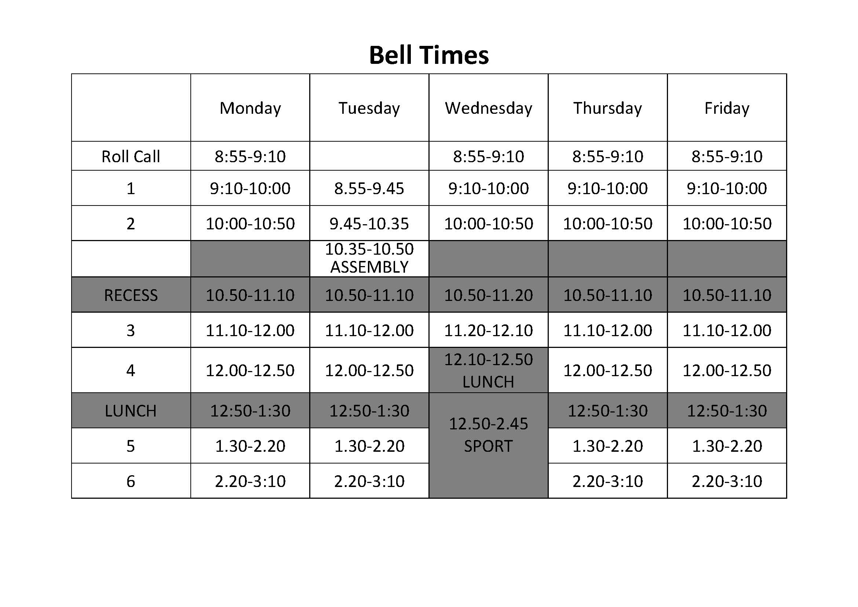
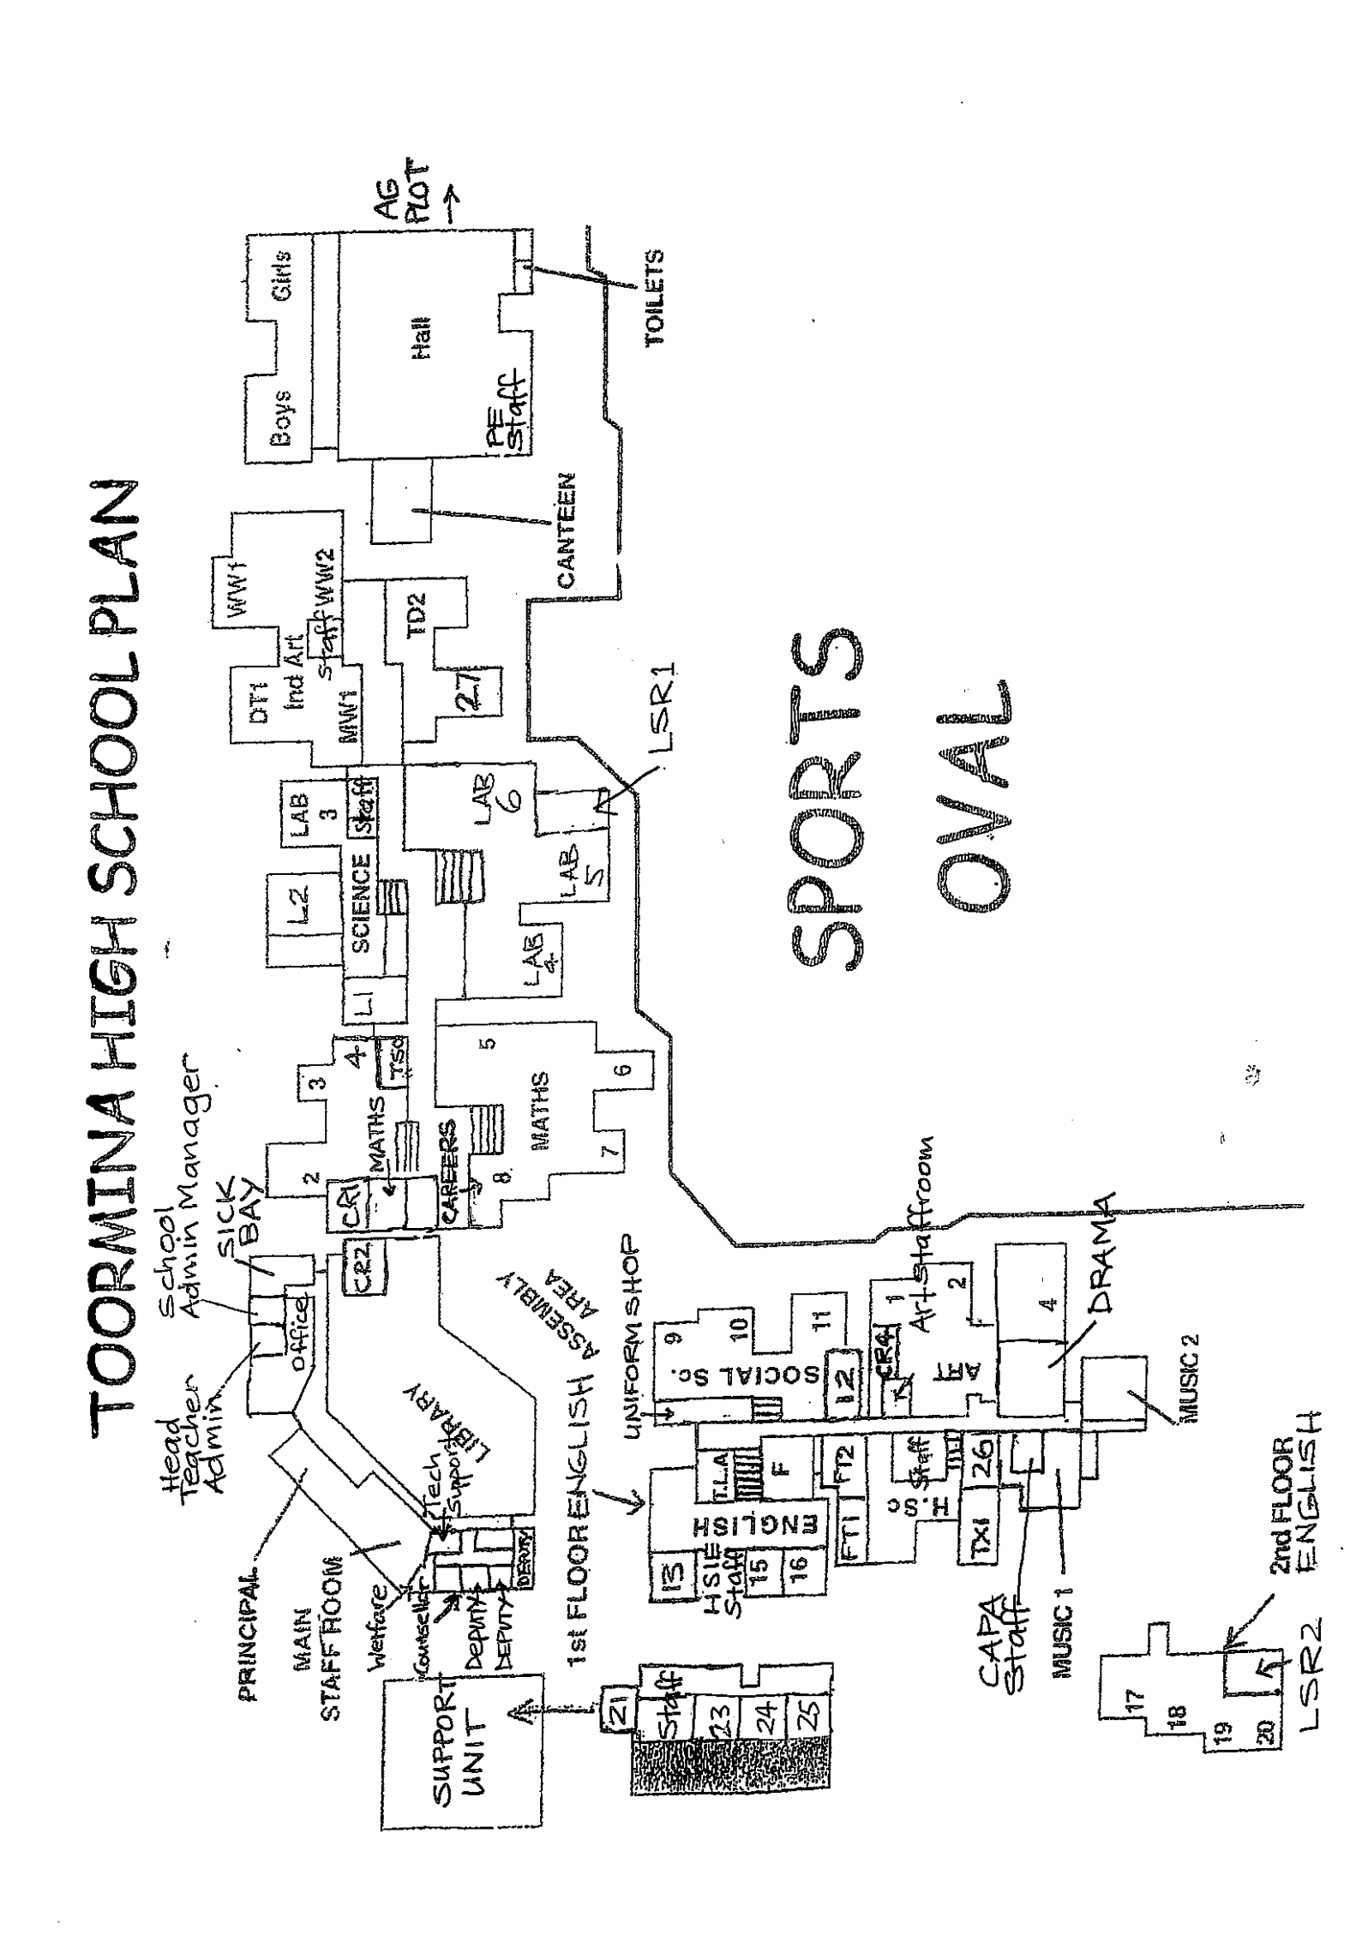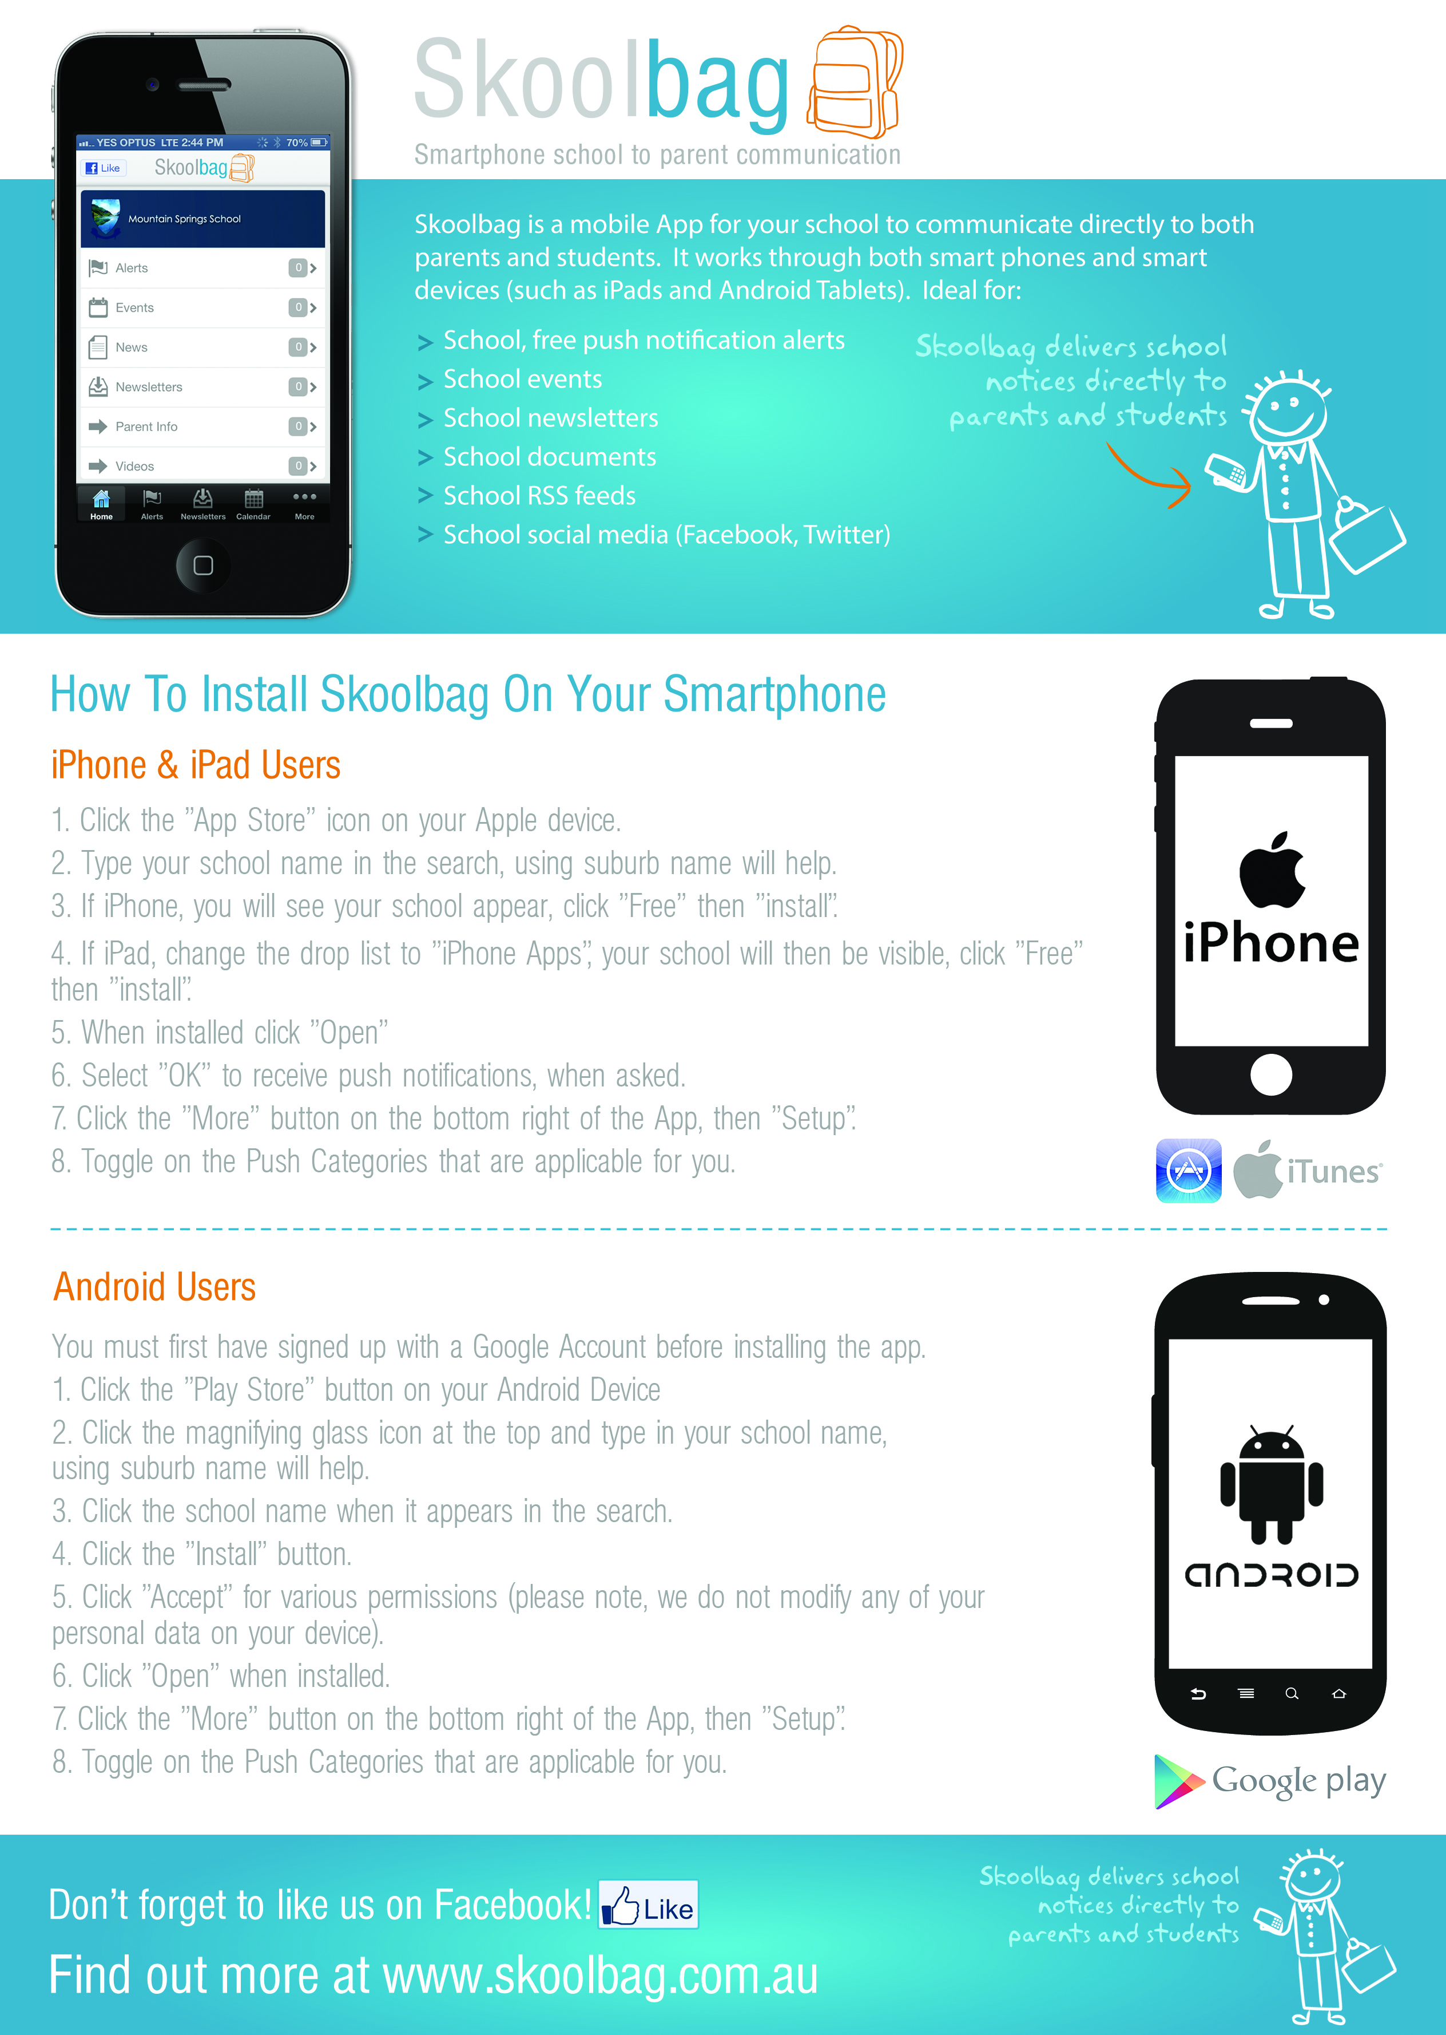
PE
STAFFROOM

