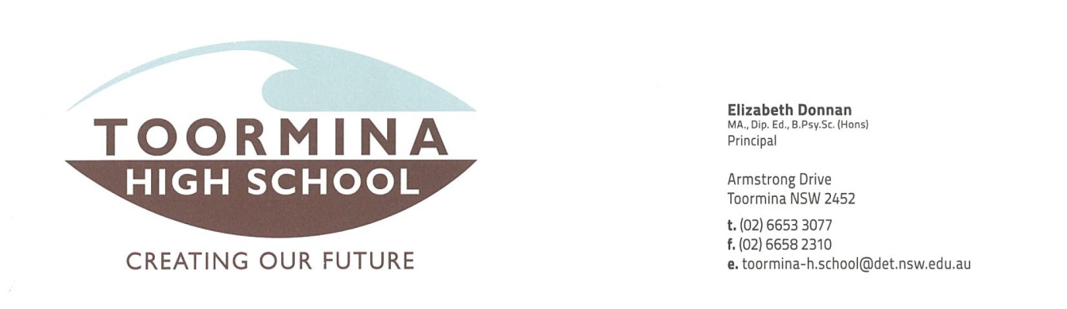

Dear Parent/Carer,
Thank you the support you have shown for Relay For Life by signing and returning the Relay For Life Registration Form and Disclaimer. In order to maintain the upmost level of care and safety for all students and in accordance with Department of Education guidelines, parents/carers need to complete the PARENTAL CONSENT FORM – OVERNIGHT EXCURSIONS and also the MEDICAL INFORMATION FORM and return it to the school office by 20/5/14. Parents/carers of students requiring medication during the event will require further consultation/interview to discuss the administration and safe keeping of the medication.

It is very important to read the following important information regarding the requirements for the relay and ensure that your son/daughter/ward is fully prepared for the excursion.
Important Relay For Life Information
- The excursion begins at 9.00 am, 31st May, at the Coffs Coast Sport and Leisure Park 2 (Stadium Drive) and concludes at 10.00 am, 1st June. The excursion DOES NOT include transportation to or from the venue.
- Students need to sign on with the Deputy Principal on arrival and will be given a security wristband indicating they are members of the Toormina High School team.
- Students need to set up their own tents (please practice this before hand as teachers will be busy with supervision and other duties). The tents need to be weatherproof and able to keep the occupants dry during rainy conditions. Tents can only contain students of the same gender. Students are only permitted to be in their allocated tent (no visiting other tents). All tents will have a list containing the names of the occupants attached to the outside of the tent.
- This is an outdoor event. There is no access to electricity. The sports field lighting will operate during the night. There are no showering facilities (students are able to wash their hands).
- It is likely to be very cold. It may rain during the day and night (this is not uncommon). Parents/carers and students need to be aware that participants are expected to endure a reduced level of comfort during the event (although this is what makes the event so rewarding).
- It is vital that students bring appropriate clothing. This should include clothing that will protect from the sun during the day. Appropriate warm clothing (shirt, jumper AND jacket, beanie, two layers of socks, gloves, tracksuit pants and tights) for when it is cold. Suitable footwear is needed, such as, boots or gumboots as the track will become muddy. Please bring a change of clothes in case clothing gets wet. Students also need an umbrella (a raincoat would also be appropriate).
- Students will be required to walk for approximately 30 minutes at least 4 times during the event (except where modifications are made for students with mobility issues or other disabilities). Parents/carers should ensure that students are fit and well on the day of the relay. If students are injured or sick on the day of the relay please consider keeping them at home as the conditions at the event may exasperate the injury or sickness. Please consult a medical professional if needed.
- The school will NOT be providing meals at the event. Students must bring sufficient funds to purchase food from the many charity food stalls at the event. Alternatively, students may choose to bring their own food from home (this may be appropriate for students with special diets). Please be aware that there are NO facilities for heating food or refrigerating food. The relay does provide a simple cereal and fruit breakfast on the Sunday morning. Be aware that food purchased at the event contributes to the Cancer Council.
- Students are not allowed to leave the venue to purchase food from outside venues (this includes McDonalds which is in the vicinity).
- Students are not to leave the event. This includes wandering away from the designated areas (our site, the track, the food stalls). If unforseen circumstances arise parents/carers need to present themselves to the Deputy Principal at the event in order to sign a student out from the event.
- Only members of the Toormina High School team are permitted at our site. Friends, boyfriends/girlfriends, relatives and even other Toormina students (from other teams) will not be permitted and students should not invite them.
- The main focus of this event involves raising money for the Cancer Council. It is expected that students will collect at least $50 (donations over $2 are tax deductible and tax receipts can be issued on request). Please bring your sponsors sheets and money into the school by the 30th of May. We will accept the sheets and money on the day, however, this is much more difficult and we do not wish to be guarding large amounts of cash.

Summary of Equipment
- $$ MONEY for MEALS $$ (or your own food)
- TENT, pillow, airbed/mattress (pump)
- Water bottle and Mess kit (Plastic Bowl, Cup, Plate, cutlery, tea towel) NOT DISPOSABLES
- Sleeping Bag and extra blankets (it will be COLD)
- Hat and sunscreen
- WARM CLOTHES and a change of clothes and appropriate footwear (joggers and boots etc.)
- Toiletries (toothbrush, deodorant etc.)
- Garbage bag for wet/dirty clothes
- Own chair, raincoat/jacket, umbrella, torch

There are many things that can be taken, but as it is a school event, you cannot take illicit drugs, alcohol or cigarettes for obvious reasons.
Please be aware that it is a Smoke-Free Event.
For further enquiries please contact the school on 66533077 and ask for Mr Anderson.
During the relay the Deputy Principal, Mrs McDowell, can be contacted on 0413030667.
Sincerely,
Mr Joseph Anderson
SRC Coordinator

