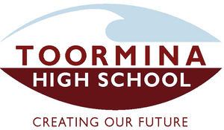
THS P&C

Toormina High School P &C are holding a Pie Drive to raise valuable funds to assist the staff and students at Toormina High School. We aim to assist with the purchase of a minibus for the school and support the education of our students.
Please purchase your pies from the order list and feel free to copy and share it with friends, neighbours and work colleagues.
Important Dates:
- All order forms and money to the front office by Wednesday 19th August 2015
- Any cheques are to be made payable to Toormina High School P & C.
- Please indicate on the order form how you would like to receive the pies by indicating if you would like to personally collect them from the school or have the pies sent home with the student listed on the order form.
- All pies will be delivered to the school and ready for dispatch on Tuesday 1st September.
Thanking you in advance, we appreciate your support.

Toormina High School P & C Committee
