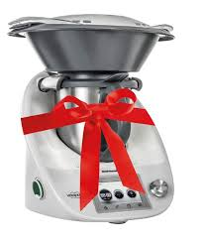
THS P&C

Win a Thermomix!
Toormina High School P &C are holding a raffle for one lucky person to win the latest Thermomix to help create fabulous, timesaving meals for your family.
With a 1 in 400 chance of winning this fabulous product, valued at over $2000, this is the perfect gift for Mothers Day or anyone who enjoys cooking.
Tickets are only $10 each and the raffle will be drawn in time for Mothers Day. Imagine how special mum will feel winning such a sought after prize!
To enter the draw, simply complete the details below and return your entry and $10 to the front office by no later than Thursday 5th May 2016.
Anyone who purchases one or more tickets will have their proof of entry either emailed or texted to them

...........................................................................................................................................

Name for ticket: _____________________________________

Student name: ________________________________ Year: ______________

Contact phone number for ticket/s: _____________________________________

Contact Email for ticket /s:_______________________________________

I would like to purchase ( ) ticket/s. Please find enclosed ($ ) to purchase the tickets.

